Git-HOL Exercise -2:
Steps:
-Create .gitignore file
- Add and commit .gitignore
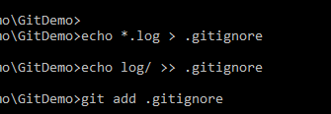
-Test ignoring
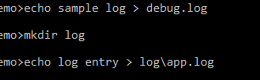
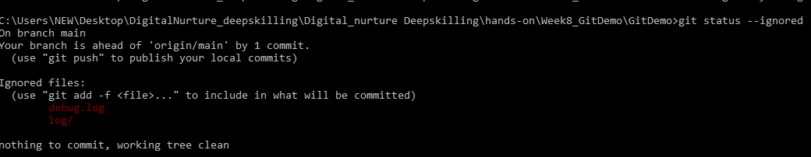
-Push changes
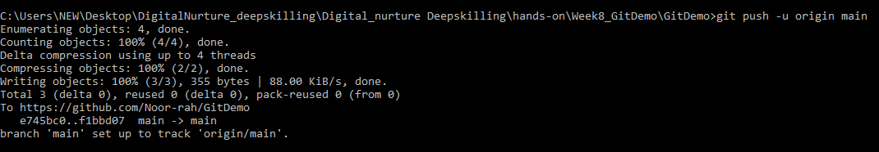

OUTPUT:
